BIO
Sounds of New Wine

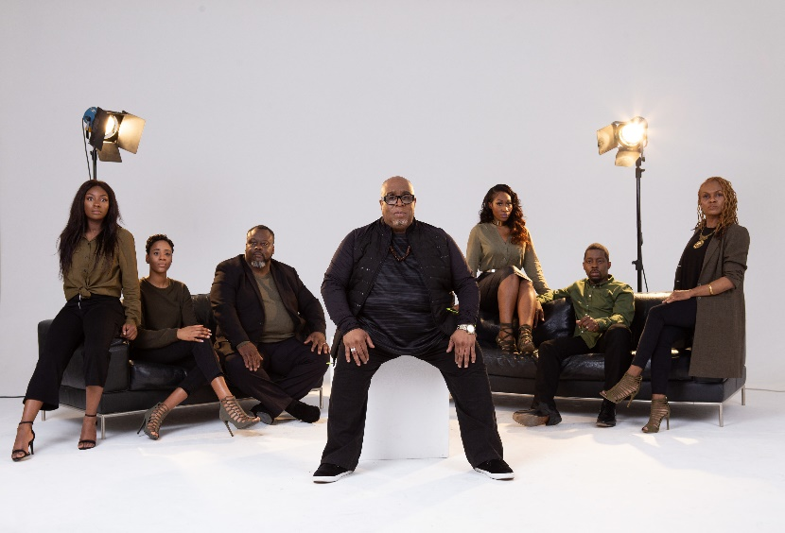
New Wine Church is a megachurch based in Woolwich, London with major influence all around the UK. They have housed world renowned pastors like Pastor Creflo Dollar and TD Jakes. The founding pastor Tayo Adeyemi had a vision of the church releasing music. Four years after his passing, the church is finally realising his dream.

To help them along, they enlisted Lawrence Johnson, a creative director, vocal trainer, arranger and vocal producer with over 30 years’ experience in the music industry. This music mogul is the cofounder of London Community Gospel Choir (LCGC), has worked closely with Simon Cowell on X Factor and has most recently worked with Sam Smith on his latest album. He is now the Creative Director of the Church’s music ministry.

Lawrence said “Since Pastor Tayo shared the vision of us releasing music, we have been developing and nurturing the vision as a church for many years. We feel God telling us that now is the time to tell our story of what we have been through and how we’re still standing.”

Made up of a team of 55, Sounds of New Wine is releasing a contemporary worship album called ‘The Siege Is Over’. Prior to this, they will be releasing 2 singles. The first one ‘God Of The Impossible’ dropped on the 14th September and has won ‘Track of the week’ on Premier Gospel as well as being featured on Heartsong Live and BBC. The second ‘Your Love’ will be released on 16th November. The much-awaited album will then drop on the 30th November.

Sounds of New Wine is hoping that the album delivers a message of hope as they declare through song that New Wine Church is an army of people who will not bow down to the difficulties of life because of the love of God.

