BIO
WYLD

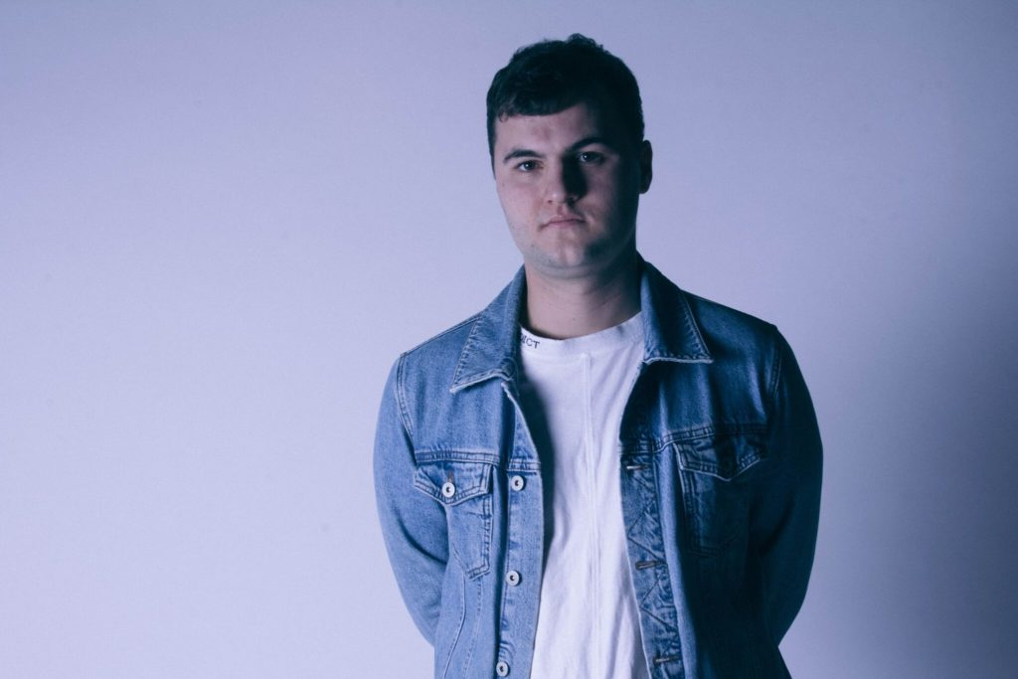
Paul Wyld is an artist from a small island in England called Guernsey.

From a tender age of 3, his parents realised he was very music oriented as he was always tapping away to Fleetwood Mac. To encourage his gifting, they got him drumming and piano lessons. From there, he self-taught himself how to play bass and guitar.

Paul got into producing when he started creating tracks for churches and bands and this is how he discovered the area of music he wanted to focus on.

After making the bold and unpopular decision to leave school at 18, he started working in graphic design. However, feeling like he didn’t have enough time to focus on his music, in 2015, he made another bold decision to quit his job and move to Manchester to pursue his music career full time.

Since then, Paul has worked with the likes of CASS, Soul Survivor, Twelve24 and Chris Howland, branding himself as a producer-artist.

After a handful of previous releases, under the name ‘This’ including remixes with Soul Survivor, Joe Bright and Chris Howland, WYLD now sets to carve out a new path in the worship music scene. Fuelled by a passion for good, forward thinking music that sits anywhere between hip-hop, pop and electronica, Paul constantly breaks free of genre constraints and always brings a fresh excitement to music fans looking for something new and honest.

